Lab 6: Code and Branch Coverage Analysis
NAME:MANDAGANDLA JHANSI
SRN:PES1UG24CS672
SECTION:L

1: Initial Code coverage
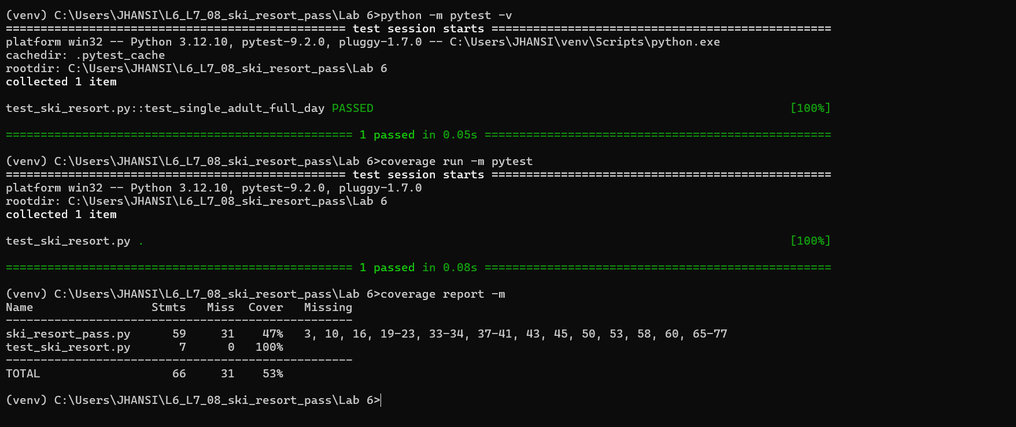
2: Initial branch coverage report
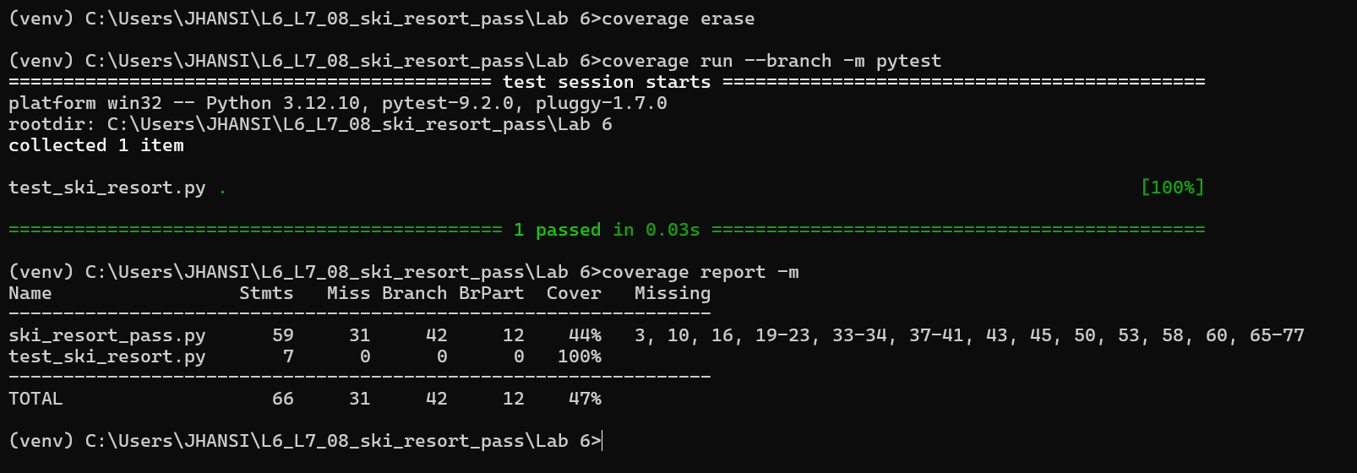
3:Final code coverage report
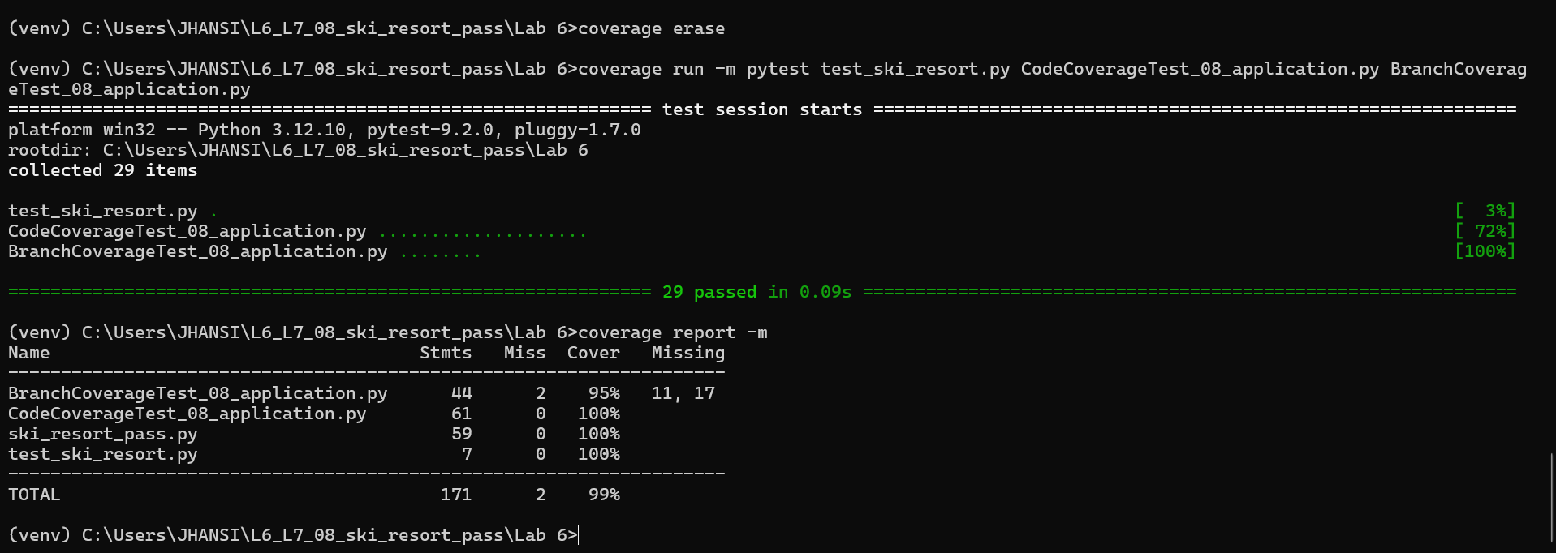
4:Final branch coverage report
